**PRELIMINARY**

XENSIV™ Multigas NO2/O3

1st Generation

Characterization ASIC and FW

2021-03-25

For internal use only

# Table of Contents

1 Table of Contents 2

2 Product Description 3

3 Principle of operation 4

3.1 Overview 4

4 Pin out 6

5 Electrical characteristics 7

6 ASIC 9

7 Firmware BOYLE 13

7.1 Commands 14

7.2 All routines 18

7.2.1 Initialization step 18

7.2.2 Autoscale 19

7.2.3 Measure PID offset 20

7.2.4 Selftime mode 21

8 Register Description 22

8.1 Bit access terminology 22

8.2 Register map 23

8.3 Sensor result registers 25

8.4 Chip ID registers 30

8.5 Measurement mode configuration register 31

8.6 Sensor status register 32

8.7 Interrupt configuration registers 33

8.8 Filter configuration registers 35

8.9 Clock modus register 36

8.10 Auto zero register 37

8.11 Measurement selection configuration registers 38

8.12 DAC registers 39

8.13 Heater loop configuration registers 40

8.14 MISC control register 43

8.15 Power configuration registers 44

8.16 Special register 45

8.17 Signature registers 46

8.18 eFUSE shadow registers 47

8.19 Test register 57

8.20 Tweak register 60

8.21 FUSE control register 61

8.22 Scan mode register 62

# Product Description

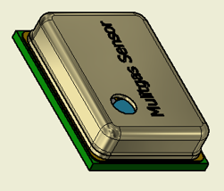The XENSIV™ MGS NO2/O3 uses a revolutionary material to sense both NO2 and O3 gases with high accuracy. Thanks to its high sensitivity, the device detects resistance variations caused by the adsorption of gas molecules at the surface of its sensing elements. An integrated ASIC captures the resistance and makes them available to be read via an I2C interface. Those data can then be further processed in order to derive an NO2 and an O3 concentration in ppb.

Exceptionally small form factor and SMD capability makes the device easy to integrate into numerous consumer products.

**Features**

* NO2 concentration detection range: 0 to 360 ppb.
* O3 concentration detection range: 0 to 165 ppb.
* Accuracy: ±50% (NO2 & O3 concentration ranging from 20 to 150ppb).
* Lifetime: 10 years at tbd measurement/minute.
* Operation temperature: 0-45°C.
* Relative humidity: 20% to 80% at 25 °C
* Interface and compensation: I2C.
* Single supply voltage: 3.3V.
* Package dimensions: 4 x 3 x 1 mm³

Special feature:

* Power-down mode to reduce the power consumption when device not in use to less than 30µA
* Control loop for gas sensor temperature monitoring and driving
* On-chip temperature sensor to monitor ambient/ASIC temperature
* Interrupts to signal temp_OK and end-of-measurement
* E-fuses with trimming values for sensor calibration

# Principle of operation

The principle of operation of the device is depicted below:



**Fig. 3.1**: MGS NO2/O3 sensor system overview

## Overview

The device hardware consists of two parts:

* Hardware element: MEMS and ASIC packaged into a single device.
* Firmware element, running on the end-application microcontroller.

The MEMS consists in:

* 4 sensing fields, on which functionalized material has been deposited.
* A heater allowing to control the temperature of the sensing fields.
* A temperature sensor allowing to read out the temperature of the sensing fields.

The design of the MEMS must ensure a homogenous distribution of the temperature across the die.

In presence of the target gases, the resistance of the sensing fields changes. The function of the ASIC is to:

* Control the temperature of the MEMS, by supplying the heater with current and reading the feedback form the temperature sensor.
* Acquire the signals coming from the sensing fields. Acquisition includes among other: select the optimal operating point, filter the signal and compensate for part to part variations thanks to calibration data fused during productive test.
* Communicate with the application microcontroller via I2C interface.

The firmware consists of 3 level

* Level 1: Low level driver to control the ASIC.
* Level 2: Pre-processing of the read data. This includes among other: signal conditioning (such as averaging, filtering); Baseline drift correction; feature extraction.
* Level 3: Data processed to provide an estimation of the concentration of NO2 and O3.

# Pin out

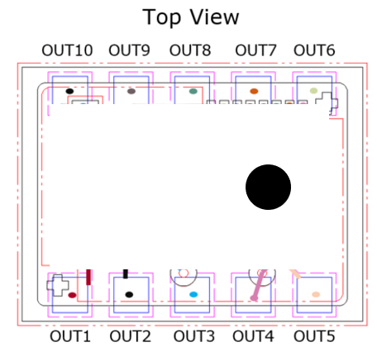

**Fig. 3.1**: MGS NO2/O3 sensor system overview

1. Pin description

| Package pad | Symbol | Function |
| --- | --- | --- |
| OUT1 | VDD | 3.3 V power supply |
| OUT2 | VSS | Ground |
| OUT3 | VDDH | Power supply for heater (3.3 V) |
| OUT4 | VDDIO | 3.3 V power supply for I2C |
| OUT5 | ExtR_in | External reference resistor (will be removed) |
| OUT6 | ExtR_out | External reference resistor (will be removed) |
| OUT7 | SCL | I2C clock pin (3.3 V domain) |
| OUT8 | SDA | I2C data pin (3.3 V domain) |
| OUT9 | INT | Interrupt output pin (3.3 V domain) |
| OUT10 | VSS | Ground |

# Electrical characteristics

1. Absolute maximum ratings

| Parameter | Symbol | Value | | Unit |
| --- | --- | --- | --- | --- |
| Min | Max |
| Supply voltage | VDD, VDDIO | -0.9 | 4.0 | V |
| I/O voltage range | All others | -0.9 | 4.0 | V |
| Heater voltage range1) | HTR1, HTR2 | -0.9 | 14.0 | V |
| Operating case temperature | TC | -55 | 150 | °C |
| Storage temperature range | Tstg | -55 | 150 | °C |

1) valid for A11; version A21 has a lower RdsON driver with only VDD range allowed

1. Recommended operating conditions

| Parameter | Symbol | Value | | | Unit |
| --- | --- | --- | --- | --- | --- |
| Min | Typ. | Max |
| Supply voltage | VDD | 3.0 | 3.3 | 3.6 | V |
| VDDIO | 1.65 | 3.3 | 3.6 | V |
| VSS, VSSH |  | 0 |  | V |
| IO voltage | INT, SDA, SCL (open drain) | 1.65 | 3.3 | 3.6 | V |
| Analog I/O | R0-R9, RREF, Vbridge1-3 | 3.0 | 3.3 | 3.6 | V |
| Heater driver1) | HTR1, HTR2 | 10 | 12 | 13.2 | V |
| Analog test I/F | DCTP, DCTN | 3.0 | 3.3 | 3.6 | V |
| Digital test I/F | Scan_en, Scan_rstn | 1.65 | 3.3 | 3.6 | V |
| Output voltage low | VOL | -40 |  | 125 | °C |

1) valid for A11; version A21 has a lower RdsON driver with only VDD range allowed



Only for ASIC. Whole system will be updated

# ASIC

The device measures the resistance of the sensors fields by applying a predefined current and measuring the voltage across the sense inputs to the reference voltage Vbridge. The device can address up to two sensors with up to four sense fields on each. A separate input is used to monitor the temperature of the sensor by means of a dedicated element with a pre-defined temperature coefficient. The device controls the temperature of the sensor by modulating the output power on the heater. A programmable on-chip PID controller takes care that the target temperature is reached and maintained before and during the measurement. The different field inputs are selectable via I²C through an analogue multiplexer. The internal state machine will execute the readout of the desired channels and provide the results as digital values in the result registers.

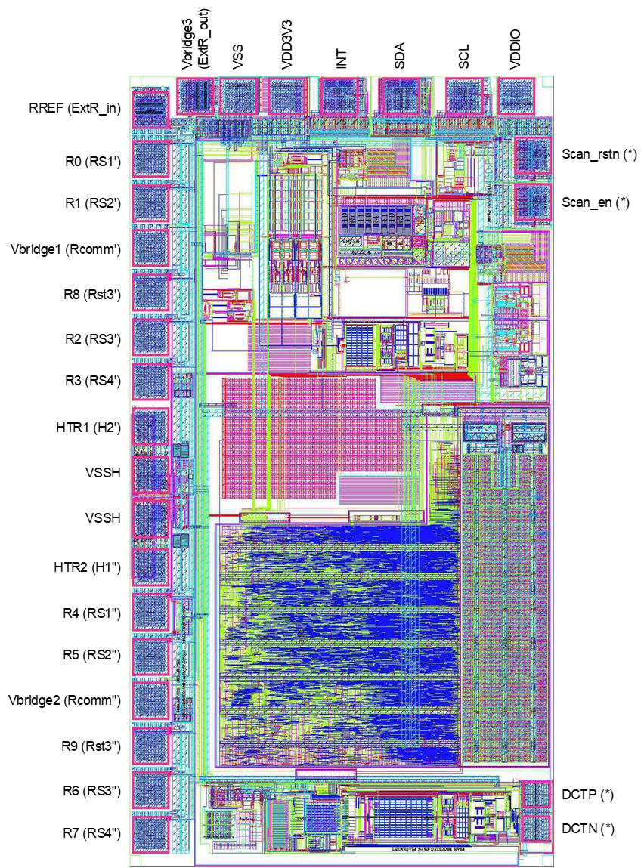

**Fig. 6.1**: ASIC

1. Pin description

| Package pad | Symbol | Function |
| --- | --- | --- |
| 1 | DCTN (*) | Analog test bus |
| 2 | DCTP (*) | Analog test bus |
| 3 | Scan_en (*) | Scan enable pad |
| 4 | Scan_rstn (*) | Scan reset pad |
| 5 | VDDIO | 3.3 V power supply for I2C and general-purpose pad |
| 6 | SCL | I2C clock pin (3.3 V domain) |
| 7 | SDA | I2C data pin (3.3 V domain) |
| 8 | INT | Interrupt output pin (3.3 V domain, open drain) |
| 9 | VDD3V3 | 3.3 V power supply (main LDOs) |
| 10 | VSS | Ground |
| 11 | Vbridge3 (ExtR_out) | DAC Voltage for optional external resistor (not used in BOYLE 2.0) |
| 12 | RREF (ExtR_in) | DAC Voltage for optional external resistor (not used in BOYLE 2.0) |
| 13 | R0 (RS1’) | Resistor sense field 1 connection of the 1st MEMS sensor |
| 14 | R1 (RS2’) | Resistor sense field 2 connection of the 1st MEMS sensor |
| 15 | Vbridge1 (Rcomm’) | DAC Voltage for 1st MEMS sensor |
| 16 | R8 (Rst3’) | Rtemp connection of the 1st MEMS sensor |
| 17 | R2 (RS3’) | Resistor sense field 3 connection of the 1st MEMS sensor |
| 18 | R3 (RS4’) | Resistor sense field 4 connection of the 1st MEMS sensor |
| 19 | HTR1 (H2’) | Supply of MEMS heater of 1st sensor |
| 20 | VSSH | Ground for heater |
| 21 | VSSH | Ground for heater |
| 22 | HTR2 (H1’’) | Supply of MEMS heater of 2nd sensor (not used) |
| 23 | R4 (RS1’’) | Resistor sense field 1 connection of the 2nd MEMS sensor (not used) |
| 24 | R5 (RS2’’) | Resistor sense field 2 connection of the 2nd MEMS sensor (not used) |
| 25 | Vbridge2 (Rcomm’’) | DAC Voltage for 2nd MEMS sensor (not used) |
| 26 | R9 (Rst3’’) | Rtemp connection of the 2nd MEMS sensor (not used) |
| 27 | R6 (RS3’’) | Resistor sense field 3 connection of the 2nd MEMS sensor (not used) |
| 28 | R7 (RS4’’) | Resistor sense field 4 connection of the 2nd MEMS sensor (not used) |

Features:

* Resistive readout with integrated 16bit Sigma-Delta ADC
* Ratiometric measurement to internal reference resistors
* Supports connection of external precision resistor
* Integrated digital temperature control loop for the heater
* Integrated ASIC temperature sensor to monitor system temperature
* Supports a maximum of two sensors with up to four channels each
* I²C communications
* OTP memory for calibration and trimming

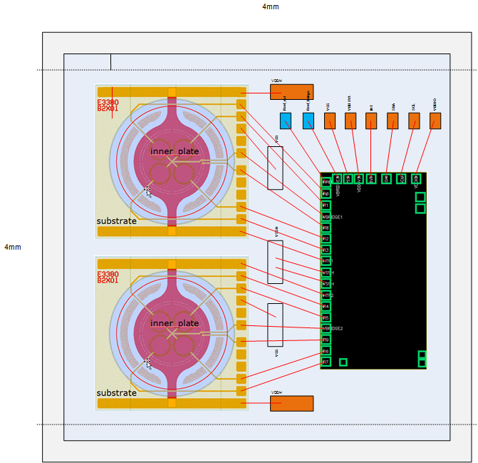

**Fig. 6.2**: ASIC with two MEMS (obsolete)

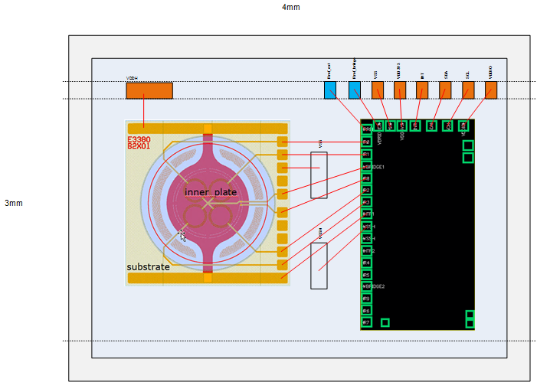

**Fig. 6.3**: ASIC with one MEMS

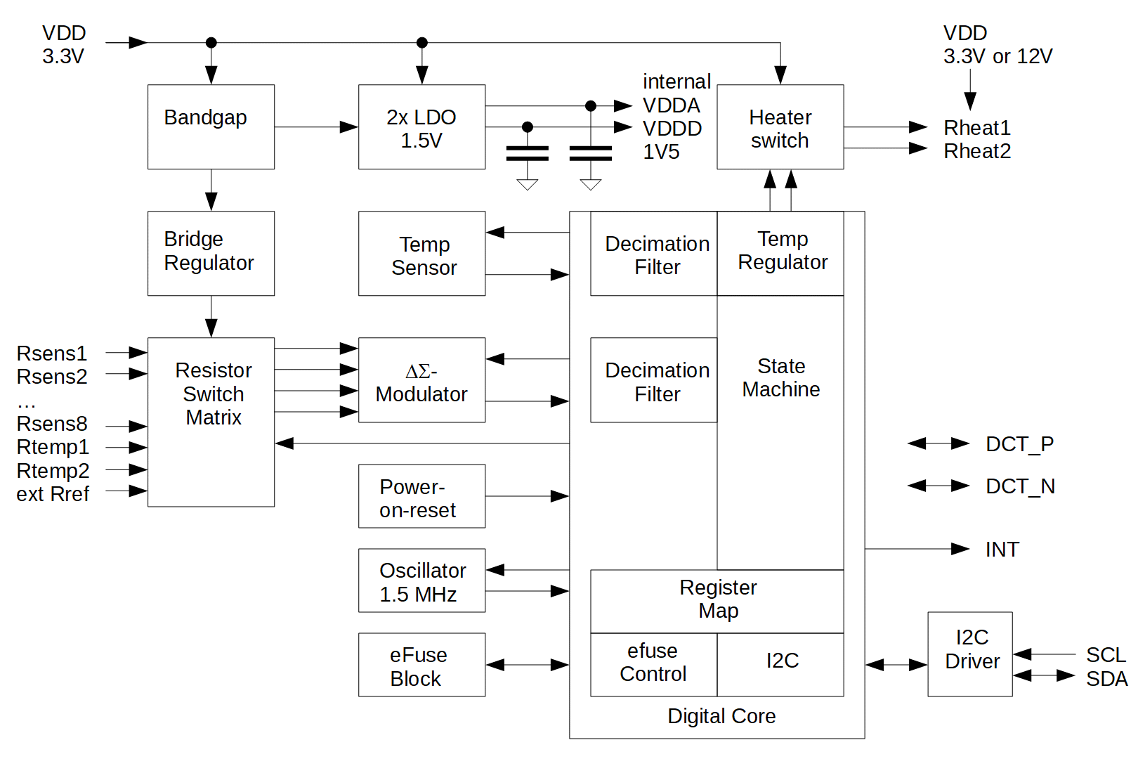

**Fig. 6.4**: ASIC block diagram

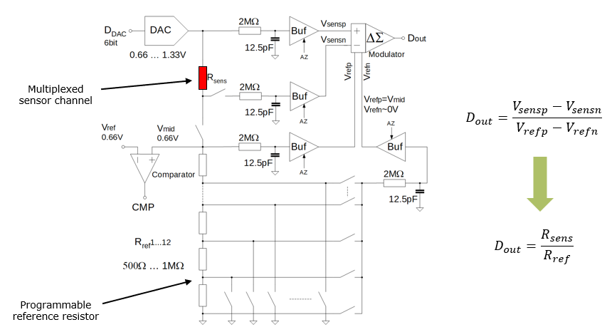

**Fig. 6.5**: Resistor measurement concept

# Firmware BOYLE

The main purpose of the firmware is to communicate with the Multigas ASICs and provide an interface via a virtual COM port to the host. 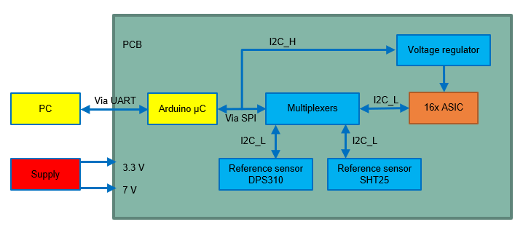

**Fig. 7.1**: Block diagram of BOYLE setup 16x board

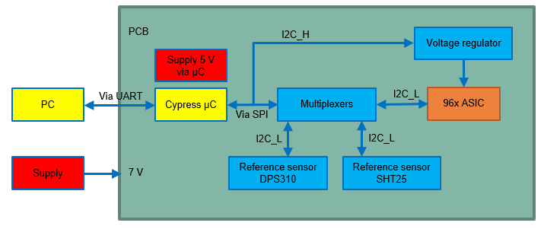

**Fig. 7.1**: Block diagram of BOYLE setup 96x board

Description 16x board

* Voltage only 7 V needed
* 16x ASIC or 96x

## Commands

In this section the available UART commands for the GUI of the BOYLE are listed and described.

|  |  |  |
| --- | --- | --- |
| **Command** | **Answer** | **Description** |
| *IDN? | BOYLE* | Ask hardware for identifier  This command can be used to scan all COM ports for the connected hardware. |
| STOP* | - | The stop command is used to terminate the selftimed mode |
| autoscale x |  | Do autoscaling of all internal reference resistors  The best internal reference resistors for all channels and all ASICs are chosen automatically. Also, the connected external reference resistor is used to calibrate all the internal reference resistors.  x = value of external reference resistor (i.e 2000) |
| measure_pid_t_offset |  | Calibration of heater PID controller  This command needs to be executed once to calibrate the heater PID controller. Further processing of these values is handled by the firmware. |
| read_rref_settings | 16 x 5 bytes | Read settings of internal reference resistors registers  0x3B until 0x3F for all 16 ASICs. |
| SPS xx | SPS yy * | Delay time between measurements in selftimed mode  xx = delay time in ms (in hex)  yy = delay time in ms (in dec) |
| SW x y | SW u v * | Open/Close hardware switches on the PCB  x y = switch number and value (in hex)  u v = answer (in dec) |
| GBR 35 00 | 128 bytes (binary) | Block read off all ASIC registers  35 = I2C address of ASIC  00 = start address |
| adc_st_16x |  | Start ASIC selftimed mode |
| r_reg 35 xx | yy * | Read ASIC register  35 = I2C address of ASIC  xx = register address (in hex) |
| w_reg_data 35 xx yy | w_reg_data 35 uu vv * | Write ASIC registers  xx = register address (in hex)  yy = register value (in hex)  uu = register address (in dec)  vv = register value (in dec) |
| all_heaters_on | all_heaters_on * | Enable all heaters in selftimed mode |
| all_heaters_off | all_heaters_off * | Disable all heaters in selftimed mode |
| heater_t_on xx | heater_t_on yy * | On time of heater  xx = heater on time in units of 100 ms (in hex)  yy = heater on time in units of 100 ms (in dec) |
| heater_t_off xx | heater_t_off yy * | Off time of heater  xx = heater on time in units of 100 ms (in hex)  yy = heater on time in units of 100 ms (in dec) |
| heater_T_high xx | heater_T_high yy * | Heater high temperature  xx = heater high temperature in °C (in hex)  yy = (xx – rtemp_t_offset_calib_temp)/2 (in dec)  rtemp_t_offset_calib_temp = This value is stored by the measure_pid_t_offset routine. The divided by 2 in the return value is needed, because the ASIC register for the target temperature only takes values in units of 2°. |
| heater_T_low xx | heater_T_low yy * | Heater low temperature  xx = heater low temperature in °C (in hex)  yy = (xx – rtemp_t_offset_calib_temp)/2 (in dec) |
| heater_toggle_mode xx | heater_toggle_mode yy * | Mode of heater operation  0: no automatic toggling in selftimed mode  1: heater is toggled between T_high and heater off  2: heater is toggled between T_high and T_low |
| clean_on xx | clean_on yy * | On time of cleaning pulse  xx = on time cleaning pulse in units of 100 ms (in hex)  yy = on time cleaning pulse in units of 100 ms (in dec) |
| clean_off xx | clean_off yy * | Off time of cleaning pulse  xx = off time cleaning pulse in units of 100 ms (in hex)  yy = off time cleaning pulse in units of 100 ms (in dec) |
| clean_temp xx | clean_temp yy * | Clean pulse temperature  xx = cleaning pulse temperature in °C (in hex)  yy = (xx – rtemp_t_offset_calib_temp)/2 (in dec) |
| clean_shift xx | clean_shift yy * | Delay of first cleaning pulse to first heater pulse  xx = shift of cleaning pulse to heater pulse (in hex)  yy = shift of cleaning pulse to heater pulse (in dec) |
| dps310_pressure? | xx* | Read pressure from reference sensor DPS310  xx = pressure in pascal (in dec) |
| dps310_temperature? | xx* | Read temperature from reference sensor DPS310  xx = temperature in °C (in dec) |
| sht25_humidity? | xx* | Read humidity from reference sensor SHT25  xx = humidity in rH% (in dec) |
| sht25_temperature? | xx* | Read temperature from reference sensor SHT25  xx = temperature in °C (in dec) |
| E6 xx yy | E6* | Set VDD of ASIC  Xx = ASIC VDD in mV MSB (in hex)  Yy = ASIC VDD in mV LSB (in hex) |
| version? | 1.4.2020 * (i.e.) | Read out firmware version |
| reference_sensors_enabled | reference_sensors_  enabled* | Enable reference sensor readout during selftimed mode |
| reference_sensors_disabled | reference_sensors_  disabled* | Disable reference sensor readout during selftimed mode |
| ref_sens_interval xx | ref_sens_interval yy * | Interval of reference sensor readout  xx = interval of reference sensor readout (in hex)  yy = interval of reference sensor readout (in dec)  Units are samples. |
| rising_steps xx | rising_steps yy * | Number of rising steps in heater ramp mode  xx = number of rising steps in ramp mode (in hex)  yy = number of rising steps in ramp mode (in dec)  If set to zero, ramping for rising edge is disabled. |
| fallings_steps xx | fallings_steps yy * | Number of falling steps in heater ramp mode  xx = number of falling steps in ramp mode (in hex)  yy = number of falling steps in ramp mode (in dec)  If set to zero, ramping for falling edge is disabled. |
| time_per_rising_step xx | time_per_rising_step yy * | Duration of one rising step in heater ramp mode  xx = time per rising step in units of 100 ms (in hex)  yy = time per rising step in units of 100 ms (in dec) |
| time_per_falling_step xx | time_per_falling_step yy * | Duration of one falling step in heater ramp mode  xx = time per falling step in units of 100 ms (in hex)  yy = time per falling step in units of 100 ms (in dec) |

**Heater timing rectangular (one step between heater T_high and T_low)**

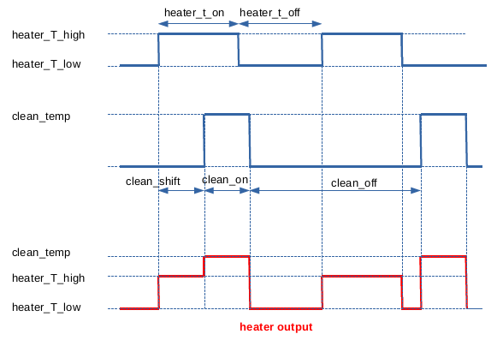

**Heater timing ramp (Ramp between heater T_high and T_low)**

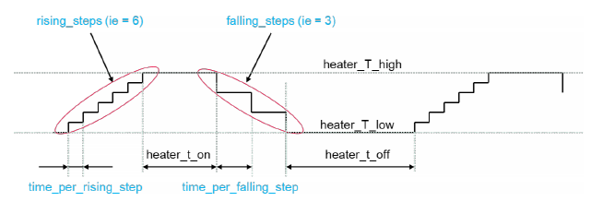

## All routines

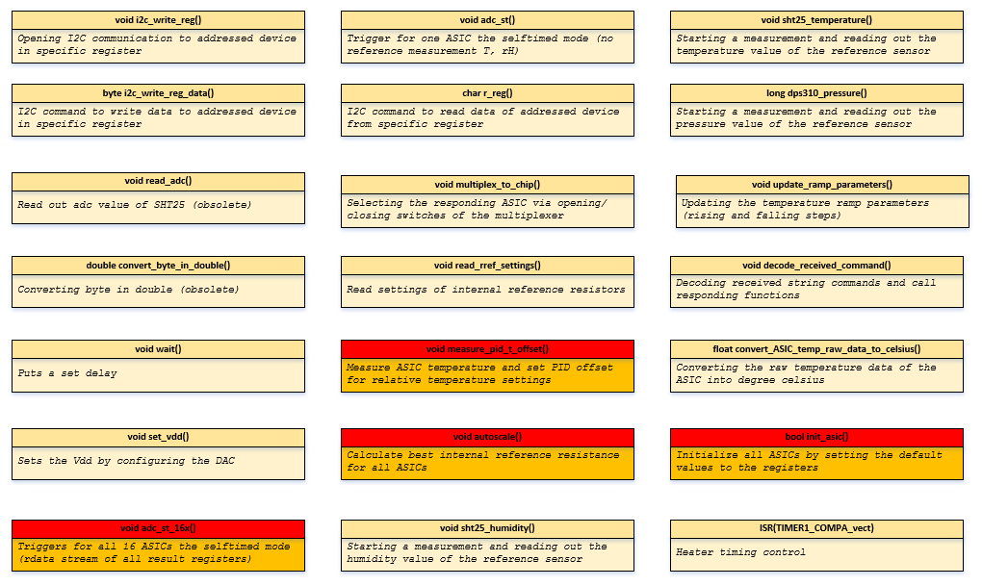

**Fig. 7.2**: All available functions in the code

### Initialization step

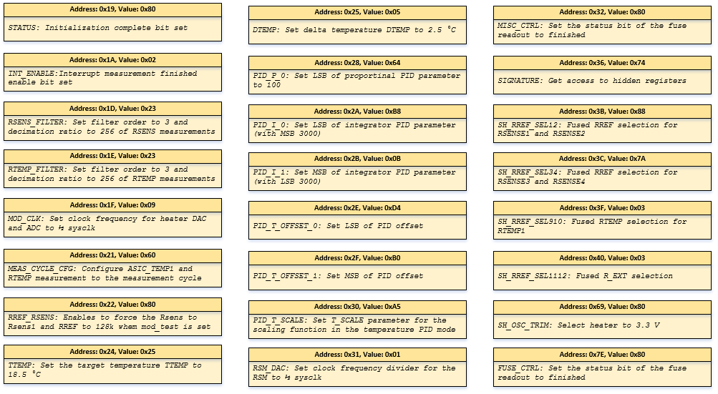

**Fig. 7.3**: Initialization step

### Autoscale

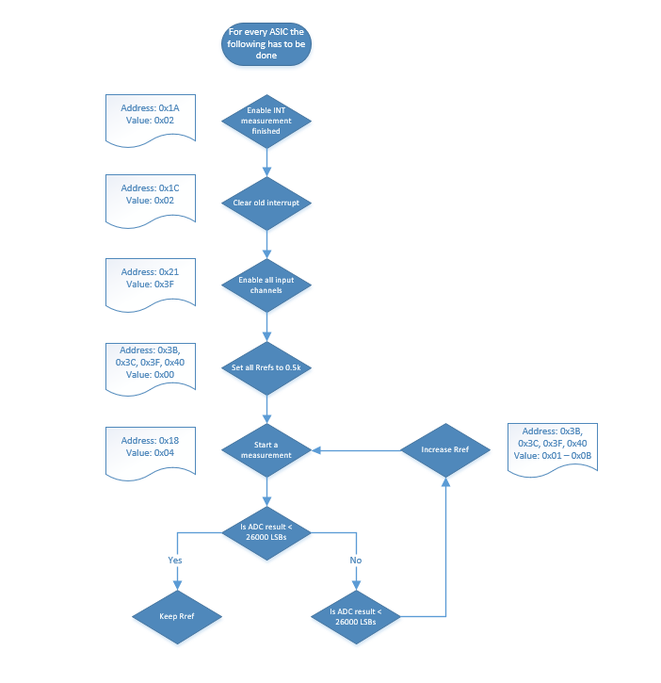

**Fig. 7.4**: Flow chart of the autoscale function

### Measure PID offset



**Fig. 7.5**: Heater temperature control loop

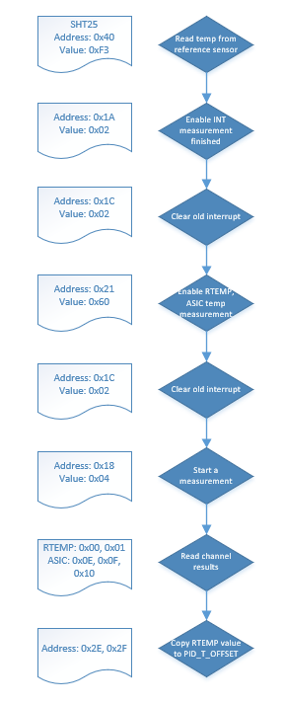

**Fig. 7.6**: Flow chart of the PID offset measurement function

### Selftime mode

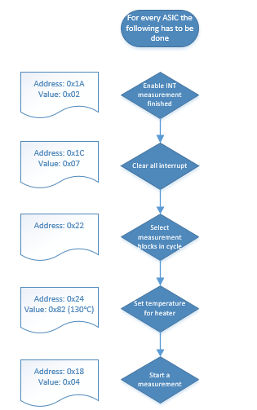

**Fig. 7.7**: Flow chart of the selftime mode

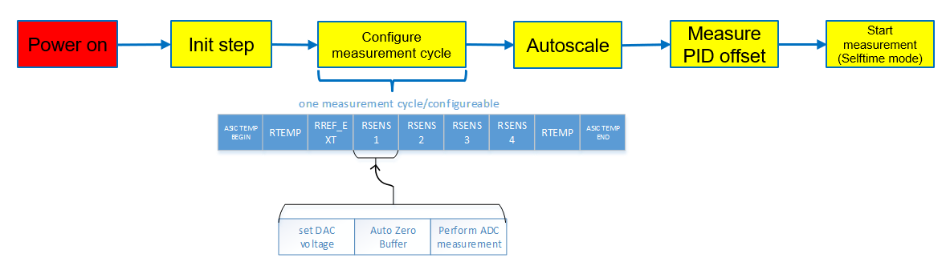

**Fig. 7.7**: Programming sequence to start a measurement

# Register Description

This section describes the registers that can be accessed by the user’s application via the communication interfaces. The registers are addressed byte-wise.

## Bit access terminology

|  |  |  |
| --- | --- | --- |
| **Mode** | **Symbol** | **Description** |
| read / write | rw | This bit or bit field can be written or read. |
| read | r | This bit or bit field is read only. |
| write | w | This bit or bit field is write only (read as 0H). |
| read / write hardware or firmware affected | rwh | As rw, but bit or bit field can also be modified by hardware or firmware. |
| read hardware or firmware affected | rh | As r, but bit or bit field can also be modified by hardware or firmware. |
| sticky | s | Bits with this attribute are “sticky” in one direction. If their reset value is once overwritten they can be switched again into their reset state only by a reset operation. Software and internal logic (except reset-like functions) cannot switch this type of bit into its reset state by writing directly the register. The sticky attribute can be combined to other functions (e.g. ‘rh’). |
| Reserved / not implemented | 0 | Bit fields named ‘0’ indicate not implemented functions. They have the following behavior:  • Reading these bit fields returns 0H.  • Writing these bit fields has no effect.  These bit fields are reserved. When writing, software should always set such bit fields to 0H in order to preserve compatibility with future products. |
| Reserved / not defined | Res | Certain bit fields or bit combinations in a bit field can be marked as ‘Reserved’, indicating that the behavior of the device is undefined for that combination of bits. Setting the register to such an undefined value may lead to unpredictable results. When writing, software must always set such bit fields to legal values |

## Register map

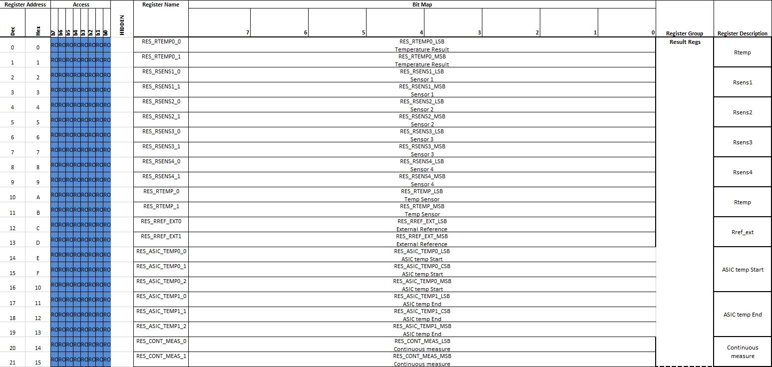

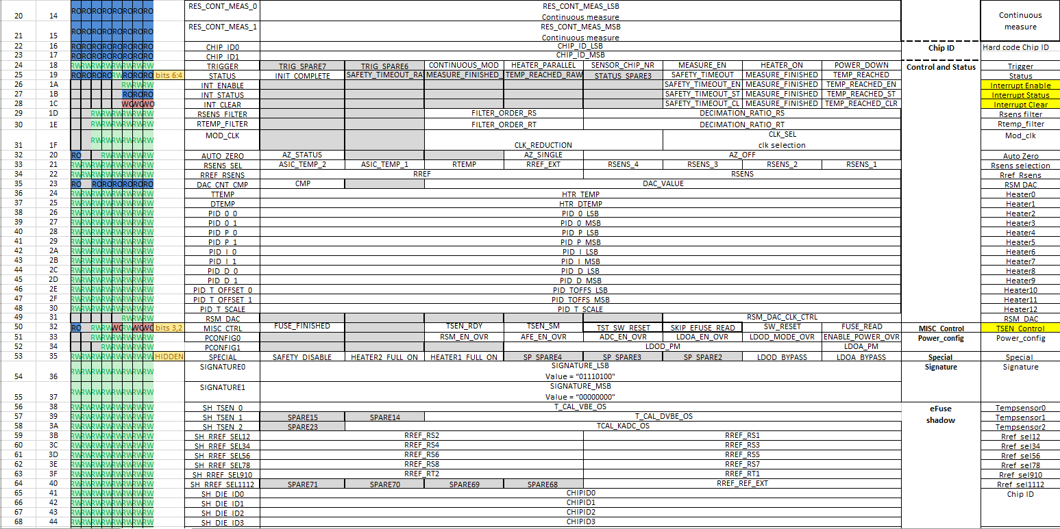

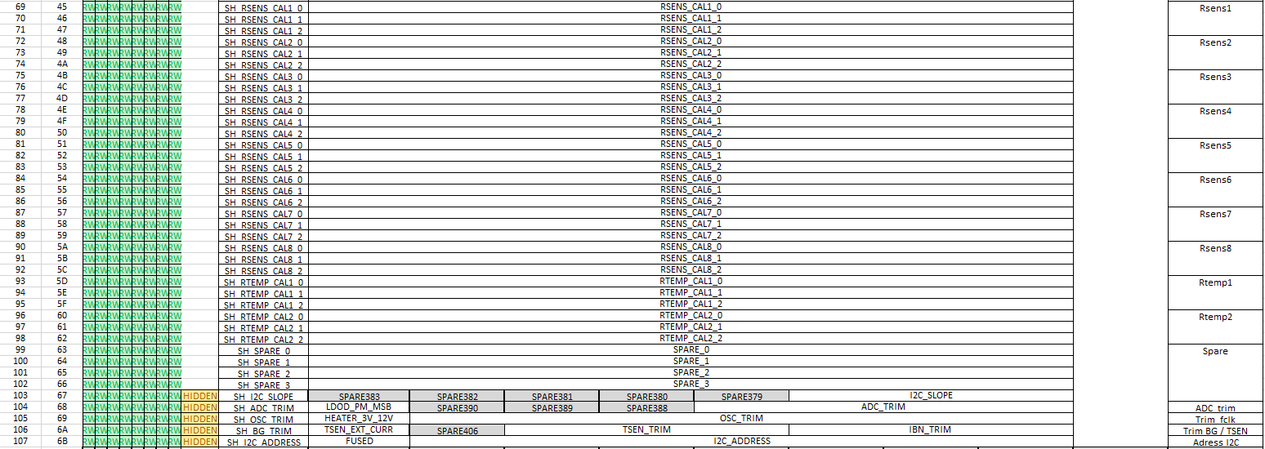

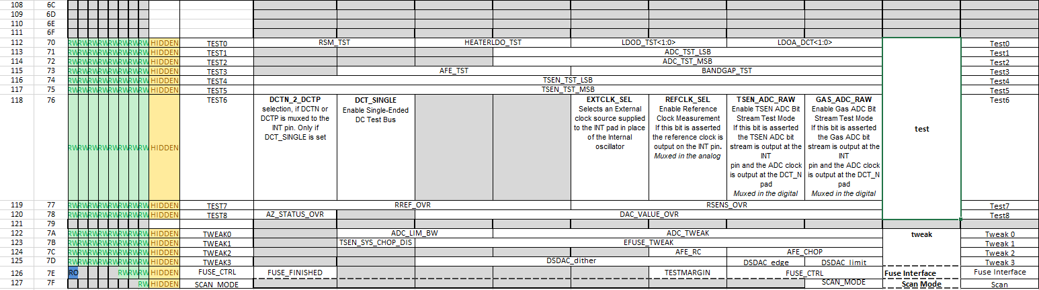

## Sensor result registers

These registers display all the measurement result of the sensor.

These measurements consist of the temperature result for the heater loop before and after the measurement cycle, the four sensing fields, the external reference resistor, the ASIC temperature before and after the measurement cycle and the result of the continuous measurement.

Which measurements will be executed can be configured in register **RSENS_SEL.**

**Register Name: RES_RTEMP0_0 Address: 0x00**

|  |  |  |  |
| --- | --- | --- | --- |
| **Field** | **Bits** | **Type** | **Description** |
| RES_RTEMP0_LSB | 7:0 | r | **LSB of Rtemp measurement result**  The concatenation of this value with bit field **RES_RTEMP0_1** gives the temperature result for the heater loop before the measurement cycle. |

**Register Name: RES_RTEMP0_1 Address: 0x01**

|  |  |  |  |
| --- | --- | --- | --- |
| **Field** | **Bits** | **Type** | **Description** |
| RES_RTEMP0_MSB | 7:0 | r | **MSB of Rtemp measurement result**  The concatenation of this value with bit field **RES_RTEMP0_0** gives the temperature result for the heater loop before the measurement cycle. |

**Register Name: RES_RTEMP_0 Address: 0x0A**

|  |  |  |  |
| --- | --- | --- | --- |
| **Field** | **Bits** | **Type** | **Description** |
| RES_RTEMP_LSB | 7:0 | r | **LSB of Rtemp measurement result**  The concatenation of this value with bit field **RES_RTEMP_1** gives the temperature result for the heater loop after the measurement cycle. |

**Register Name:** **RES_RTEMP_1 Address: 0x0B**

|  |  |  |  |
| --- | --- | --- | --- |
| **Field** | **Bits** | **Type** | **Description** |
| RES_RTEMP_MSB | 7:0 | r | **MSB of Rtemp measurement result**  The concatenation of this value with bit field **RES_RTEMP_0** gives the temperature result for the heater loop after the measurement cycle. |

**Register Name:** **RES_RSENS1_0 Address: 0x02**

|  |  |  |  |
| --- | --- | --- | --- |
| **Field** | **Bits** | **Type** | **Description** |
| RES_SENS1_LSB | 7:0 | r | **LSB of Sensor 1 result**  The concatenation of this value with bit field **RES_RSENS1_1** gives the resistance result of the first sensor field. |

**Register Name:** **RES_RSENS1_1 Address: 0x03**

|  |  |  |  |
| --- | --- | --- | --- |
| **Field** | **Bits** | **Type** | **Description** |
| RES_SENS1_MSB | 7:0 | r | **MSB of Sensor 1 result**  The concatenation of this value with bit field **RES_RSENS1_0** gives the resistance result of the first sensor field. |

**Register Name:** **RES_RSENS2_0 Address: 0x04**

|  |  |  |  |
| --- | --- | --- | --- |
| **Field** | **Bits** | **Type** | **Description** |
| RES_SENS2_LSB | 7:0 | r | **LSB of Sensor 2 result**  The concatenation of this value with bit field **RES_RSENS2_1** gives the resistance result of the second sensor field. |

**Register Name:** **RES_RSENS2_1 Address: 0x05**

|  |  |  |  |
| --- | --- | --- | --- |
| **Field** | **Bits** | **Type** | **Description** |
| RES_SENS2_MSB | 7:0 | r | **MSB of Sensor 2 result**  The concatenation of this value with bit field **RES_RSENS2_0** gives the resistance result of the second sensor field. |

**Register Name:** **RES_RSENS3_0 Address: 0x06**

|  |  |  |  |
| --- | --- | --- | --- |
| **Field** | **Bits** | **Type** | **Description** |
| RES_SENS3_LSB | 7:0 | r | **LSB of Sensor 3 result**  The concatenation of this value with bit field **RES_RSENS3_1** gives the resistance result of the third sensor field. |

**Register Name:** **RES_RSENS3_1 Address: 0x07**

|  |  |  |  |
| --- | --- | --- | --- |
| **Field** | **Bits** | **Type** | **Description** |
| RES_SENS3_MSB | 7:0 | r | **MSB of Sensor 3 result**  The concatenation of this value with bit field **RES_RSENS3_0** gives the resistance result of the third sensor field. |

**Register Name:** **RES_RSENS4_0 Address: 0x08**

|  |  |  |  |
| --- | --- | --- | --- |
| **Field** | **Bits** | **Type** | **Description** |
| RES_SENS4_LSB | 7:0 | r | **LSB of Sensor 4 result**  The concatenation of this value with bit field **RES_RSENS4_1** gives the resistance result of the fourth sensor field. |

**Register Name:** **RES_RSENS4_1 Address: 0x09**

|  |  |  |  |
| --- | --- | --- | --- |
| **Field** | **Bits** | **Type** | **Description** |
| RES_SENS1_MSB | 7:0 | r | **MSB of Sensor 4 result**  The concatenation of this value with bit field **RES_RSENS4_0** gives the resistance result of the fourth sensor field. |

**Register Name:** **RES_RREF_EXT0 Address: 0x0C**

|  |  |  |  |
| --- | --- | --- | --- |
| **Field** | **Bits** | **Type** | **Description** |
| RES_RREF_EXT_LSB | 7:0 | r | **LSB of external reference resistor result**  The concatenation of this value with bit field **RES_RREF_EXT1** gives the resistance result of the external reference resistor. |

**Register Name:** **RES_RREF_EXT1 Address: 0x0D**

|  |  |  |  |
| --- | --- | --- | --- |
| **Field** | **Bits** | **Type** | **Description** |
| RES_RREF_EXT_MSB | 7:0 | r | **MSB of external reference resistor result**  The concatenation of this value with bit field **RES_RREF_EXT0** gives the resistance result of the external reference resistor. |

**Register Name:** **RES_ASIC_TEMP0_0 Address: 0x0E**

|  |  |  |  |
| --- | --- | --- | --- |
| **Field** | **Bits** | **Type** | **Description** |
| RES_ASIC_TEMP0_LSB | 7:0 | r | **LSB of ASIC temperature result**  The concatenation of this value with bit fields **RES_ASIC_TEMP0_1** and **RES_ASIC_TEMP0_2** gives the ASIC temperature result before the measurement cycle. |

**Register Name:** **RES_ASIC_TEMP0_1 Address: 0x0F**

|  |  |  |  |
| --- | --- | --- | --- |
| **Field** | **Bits** | **Type** | **Description** |
| RES_ASIC_TEMP0_CSB | 7:0 | r | **CSB of ASIC temperature result**  The concatenation of this value with bit fields **RES_ASIC_TEMP0_0** and **RES_ASIC_TEMP0_2** gives the ASIC temperature before the measurement cycle. |

**Register Name:** **RES_ASIC_TEMP0_2 Address: 0x10**

|  |  |  |  |
| --- | --- | --- | --- |
| **Field** | **Bits** | **Type** | **Description** |
| RES_ASIC_TEMP0_MSB | 7:0 | r | **MSB of ASIC temperature result**  The concatenation of this value with bit fields **RES_ASIC_TEMP0_0** and **RES_ASIC_TEMP0_1** gives the ASIC temperature before the measurement cycle. |

**Register Name:** **RES_ASIC_TEMP1_0 Address: 0x11**

|  |  |  |  |
| --- | --- | --- | --- |
| **Field** | **Bits** | **Type** | **Description** |
| RES_ASIC_TEMP1_LSB | 7:0 | r | **LSB of ASIC temperature result**  The concatenation of this value with bit fields **RES_ASIC_TEMP1_1** and **RES_ASIC_TEMP1_2** gives the ASIC temperature after the measurement cycle. |

**Register Name:** **RES_ASIC_TEMP1_1 Address: 0x12**

|  |  |  |  |
| --- | --- | --- | --- |
| **Field** | **Bits** | **Type** | **Description** |
| RES_ASIC_TEMP1_CSB | 7:0 | r | **CSB of ASIC temperature result**  The concatenation of this value with bit fields **RES_ASIC_TEMP1_0** and **RES_ASIC_TEMP0_2** gives the ASIC temperature after the measurement cycle. |

**Register Name: RES_ASIC_TEMP1_2 Address: 0x13**

|  |  |  |  |
| --- | --- | --- | --- |
| **Field** | **Bits** | **Type** | **Description** |
| RES_ASIC_TEMP1_MSB | 7:0 | r | **MSB of ASIC temperature result**  The concatenation of this value with bit fields **RES_ASIC_TEMP1_0** and **RES_ASIC_TEMP1_1** gives the ASIC temperature after the measurement cycle. |

**Register Name:** **RES_CONT_MEAS_0 Address: 0x14**

|  |  |  |  |
| --- | --- | --- | --- |
| **Field** | **Bits** | **Type** | **Description** |
| RES_CONT_MEAS_LSB | 7:0 | r | **LSB of continuous measurement result**  The concatenation of this value with bit field **RES_CONT_MEAS_1** gives the continuous measurement result. |

**Register Name:** **RES_CONT_MEAS_1 Address: 0x15**

|  |  |  |  |
| --- | --- | --- | --- |
| **Field** | **Bits** | **Type** | **Description** |
| RES_CONT_MEAS_MSB | 7:0 | r | **MSB of continuous measurement result**  The concatenation of this value with bit field **RES_CONT_MEAS_0** gives the continuous measurement result. |

## Chip ID registers

These registers display the ASIC’s design and version ID.

16 bits are allocated, but maybe only 8 are required. These 8 bits are used to hard code electrically the version and the design step.

**Register Name:** **CHIP_ID0 Address: 0x16**

|  |  |  |  |
| --- | --- | --- | --- |
| **Field** | **Bits** | **Type** | **Description** |
| CHIP_ID_LSB | 7:3 | r | **Design step**  00000b: A11  00001b: A21  00010b : Reserved  …  11111b : Reserved |
| CHIP_ID_LSB | 2:0 | r | **Chip version**  000b: Reserved  001b: Version 1  010b : Version 2  011b : Version 3  100b: Version 4  101b: Version 5  110b : Version 6  111b : Version 7 |

**Register Name:** **CHIP_ID1 Address: 0x17**

|  |  |  |  |
| --- | --- | --- | --- |
| **Field** | **Bits** | **Type** | **Description** |
| CHIP_ID_MSB | 7:0 | r | **ASIC ID Identifier MSB (Hard code Chip ID)**  00000000b: for A11  01000111b: ASCII "G" constant for all gas ASIC products after A21 |

## Measurement mode configuration register

This register defines the operation settings of the device.

**Register Name:** **TRIGGER Address: 0x18**

|  |  |  |  |
| --- | --- | --- | --- |
| **Field** | **Bits** | **Type** | **Description** |
| **Res**  TRIG_SPARE7 | 7 | rw | **Reserved**  This bit field is read back as 0. |
| **Res**  TRIG_SPARE6 | 6 | rw | **Reserved**  This bit field is read back as 0. |
| CONTINUOUS_MOD | 5 | rw | **Continuous mode bit**  Writing this bit with 1b sets a single measurement in continuous mode (no sequence). |
| HEATER_PARALLEL | 4 | rw | **Enable parallel heater bit**  Writing this bit with 1b enables the other heater in parallel with the same DAC value. |
| SENSOR_CHIP_NR | 3 | rw | **Sensor chip selection bit**  This bit selects which sensor chip will be used for measurement.  0b: Sensor chip number 0.  1b: Sensor chip number 1. |
| MEASURE_EN | 2 | rw | **Measurement enable bit**  Writing this bit with 1b starts the measurement sequence / continuous mode measurement. |
| HEATER_ON | 1 | rw | **Heater enable bit**  Writing this bit with 1b starts the heating phase of the measurement. This bit sets **POWER_DOWN** automatically to 0b when set. |
| POWER_DOWN | 0 | rw | **Power disable bit**  Writing this bit with 1b disables the power of the whole chip. |

## Sensor status register

This register displays status information of the sensor.

**Register Name: STATUS Address: 0x19**

|  |  |  |  |
| --- | --- | --- | --- |
| **Field** | **Bits** | **Type** | **Description** |
| INIT_COMPLETE | 7 | r | **Initialization complete bit**  This bit indicates when the initialization of the sensor after power-up has been completed. |
| **Res**  SAFETY_TIMEOUT_RAW | 6 | r | **Reserved**  This bit field is read back as 0. Hidden: Visible only when signature is written. |
| **Res**  MEASURE_FINISHED_RAW | 5 | r | **Reserved**  This bit field is read back as 0. Hidden: Visible only when signature is written. |
| **Res**  TEMP_REACHED_RAW | 4 | r | **Reserved**  This bit field is read back as 0. Hidden: Visible only when signature is written. |
| **Res**  STATUS_SPARE3 | 3 | rw | **Reserved**  This bit field is read back as 0. Hidden: Visible only when signature is written. |
| SAFETY_TIMEOUT | 2 | r | **Safety timeout bit**  This bit indicates if the safety timeout for the heater has been reached and is causing the disabling of the heater output. |
| MEASURE_FINISHED | 1 | r | **Measurement finished bit**  This bit indicates when a measurement cycle has been completed. |
| TEMP_REACHED | 0 | r | **Temperature reached bit**  This bit indicates when the measured heater temperature has reached the required range from the target value. |

## Interrupt configuration registers

This register defines the configuration of the interrupt.

**Register Name**: **INT_ENABLE Address: 0x1A**

|  |  |  |  |
| --- | --- | --- | --- |
| **Field** | **Bits** | **Type** | **Description** |
| 0 | 7:3 | 0 | **Reserved**  This bit field is read back as 00000b. |
| SAFETY_TIMEOUT_EN | 2 | rw | **Safety timeout interrupt enable bit**  Writing this bit with 1b configures pin **INT** as safety timeout notification pin. |
| MEASURE_FINISHED_EN | 1 | rw | **Measurement finished enable bit**  Writing this bit with 1b configures pin **INT** as measurement finished notification pin. |
| TEMP_REACHED_EN | 0 | rw | **Temperature reached interrupt enable bit**  Writing this bit with 1b configures pin **INT** as temperature reached notification pin. |

**Register Name**: **INT_STATUS Address: 0x1B**

|  |  |  |  |
| --- | --- | --- | --- |
| **Field** | **Bits** | **Type** | **Description** |
| 0 | 7:3 | 0 | **Reserved**  This bit field is read back as 00000b. |
| SAFETY_TIMEOUT_ST | 2 | r | **Safety timeout interrupt status bit (sticky bit, tbc)**  This bit indicates if pin **INT** has been latched to active state in case of safety timeout.  0b: Pin **INT** has not been latched to active state.  1b: Pin **INT** has been latched to active state.  This bit is cleared by setting bit **INT_CLEAR.SAFETY_TIMEOUT_CLR** |
| MEASURE_FINISHED_ST | 1 | r | **Measurement finished interrupt status bit (sticky bit, tbc)**  This bit indicates if pin **INT** has been latched to active state in case of measurement finished.  0b: Pin **INT** has not been latched to active state.  1b: Pin **INT** has been latched to active state.  This bit is cleared by setting bit **INT_CLEAR.MEASURE_FINISHED_CLR** |
| TEMP_REACHED_ST | 0 | r | **Temperature reached interrupt status bit (sticky bit, tbc)**  This bit indicates if pin **INT** has been latched to active state in case of temperature reached.  0b: Pin **INT** has not been latched to active state.  1b: Pin **INT** has been latched to active state.  This bit is cleared by setting bit **INT_CLEAR.TEMP_REACHED_CLR** |

**Register Name**: **INT_CLEAR Address: 0x1C**

|  |  |  |  |
| --- | --- | --- | --- |
| **Field** | **Bits** | **Type** | **Description** |
| 0 | 7:3 | 0 | **Reserved**  This bit field is read back as 00000b. |
| SAFETY_TIMEOUT_CLR | 2 | w | **Safety timeout clear bit**  Writing this bit with 1b clears the sticky bit (tbc) **INT_STATUS.SAFETY_TIMEOUT_ST** and forces pin **INT** to inactive level. |
| MEASURE_FINISHED_CLR | 1 | w | **Measurement finished clear bit**  Writing this bit with 1b clears the sticky bit (tbc) **INT_STATUS.MEASURE_FINISHED_ST** and forces pin **INT** to inactive level. |
| TEMP_REACHED_CLR | 0 | w | **Temperature reached clear bit**  Writing this bit with 1b clears the sticky bit (tbc) **INT_STATUS.TEMP_REACHED_ST** and forces pin **INT** to inactive level. |

## Filter configuration registers

These registers define the configuration of the sinc filters for the sensor fields and heater temperature measurements.

**Register Name**: **RSENS_FILTER Address: 0x1D**

|  |  |  |  |
| --- | --- | --- | --- |
| **Field** | **Bits** | **Type** | **Description** |
| 0 | 7:6 | 0 | **Reserved**  This bit field is read back as 00b. |
| FILTER_ORDER_RS | 5:4 | rw | **Filter order configuration bit**  00b: 1st order  01b: 2nd order  10b: 3rd order  11b: 3rd order |
| DECIMATION_RATIO_RS | 3:0 | rw | **Decimation ratio configuration bit**  0000b: 32  0001b: 64  0010b: 128  0011b: 256  0100b: 512  …  1010b: 32768 |

**Register Name**: **RTEMP_FILTER Address: 0x1E**

|  |  |  |  |
| --- | --- | --- | --- |
| **Field** | **Bits** | **Type** | **Description** |
| 0 | 7:6 | 0 | **Reserved**  This bit field is read back as 00b. |
| FILTER_ORDER_RT | 5:4 | rw | **Filter order configuration bit**  00b: 1st order  01b: 2nd order  10b: 3rd order  11b: 3rd order |
| DECIMATION_RATIO_RT | 3:0 | rw | **Decimation ratio configuration bit**  0000b: 32  0001b: 64  0010b: 128  0011b: 256  0100b: 512  …  1010b: 32768 |

## Clock modus register

This register defines the configuration of the clock frequency for the DAC and ADC.

**Register Name**: **MOD_CLK Address: 0x1F**

|  |  |  |  |
| --- | --- | --- | --- |
| **Field** | **Bits** | **Type** | **Description** |
| 0 | 7:6 | 0 | **Reserved**  This bit field is read back as 00b. |
| CLK_REDUCTION | 5:3 | rw | **Clock frequency for heater DAC**  000b: sysclk  001b: 1/2 sysclk (recommended)  010b: 1/4 sysclk  …  111b: 1/128 sysclk |
| CLK_SEL | 2:0 | rw | **Clock frequency for ADC**  000b: sysclk  001b: 1/2 sysclk (recommended)  010b: 1/4 sysclk  …  111b: 1/128 sysclk |

## Auto zero register

This register defines the configuration of the auto zero.

The auto zero is used to compensate the DC offset.

**Register Name**: **AUTO_ZERO Address: 0x20**

|  |  |  |  |
| --- | --- | --- | --- |
| **Field** | **Bits** | **Type** | **Description** |
| AZ_STATUS | 7 | r | **Auto zero status bit**  This bit indicates if the auto zero phase is ongoing. |
| 0 | 6:5 | 0 | **Reserved**  This bit field is read back as 00b. |
| AZ_SINGLE | 4 | rw | **Auto zero configuration bit**  1b: in continuous mode, do only once at the beginning one auto zero phase  0b: in continuous mode, one auto zero phase in advance of 3 sinc filter output clocks  This bit only affects continuous mode. |
| AZ_OFF | 3:0 | rw | **Auto zero disable bit**  Setting these bits disables the auto zero per channel.  xxx1b: adc_vinp  xx1xb: adc_vinn  x1xxb: adc_vrefp  1xxxb: adc_vrefn  This bit only affects continuous mode. |

## Measurement selection configuration registers

This register defines the configuration of one measurement cycle. How one measurement cycle is configured has an big impact of the overall timing.

**Register Name**: **RSENS_SEL Address: 0x21**

|  |  |  |  |
| --- | --- | --- | --- |
| **Field** | **Bits** | **Type** | **Description** |
| ASIC_TEMP_2 | 7 | rw | **Select ASIC temperature measurement bit**  Writing this bit with 1b enables the ASIC temperature measurement (before the measurement cycle) in the measurement sequence. |
| ASIC_TEMP_1 | 6 | rw | **Select ASIC temperature measurement bit**  Writing this bit with 1b enables the ASIC temperature measurement (after the measurement cycle) in the measurement sequence. |
| RTEMP | 5 | rw | **Select Rtemp measurement bit**  Writing this bit with 1b enables the Rtemp measurement in the measurement sequence. |
| RREF_EXT | 4 | rw | **Select external reference resistor measurement bit**  Writing this bit with 1b enables the external reference resistor measurement in the measurement sequence. |
| RSENS_4 | 3 | rw | **Select Sensor 4 measurement bit**  Writing this bit with 1b enables the measurement of the fourth sensor field in the measurement sequence. |
| RSENS_3 | 2 | rw | **Select Sensor 3 measurement bit**  Writing this bit with 1b enables the measurement of the third sensor field in the measurement sequence. |
| RSENS_2 | 1 | rw | **Select Sensor 2 measurement bit**  Writing this bit with 1b enables the measurement of the second sensor field in the measurement sequence. |
| RSENS_1 | 0 | rw | **Select Sensor 1 measurement bit**  Writing this bit with 1b enables the measurement of the first sensor field in the measurement sequence. |

**Register Name**: **RREF_RSENS Address: 0x22**

|  |  |  |  |
| --- | --- | --- | --- |
| **Field** | **Bits** | **Type** | **Description** |
| RREF | 7:4 | rw | **Reserved**  This bit field is read back as 00b. |
| **Res**  RSENS | 3:0 | rw | **Reserved** |

## DAC registers (TBD onwards)

This register defines the configuration of the interrupt.

**Register Name**: **DAC_CNT_CMP Address: 0x23**

|  |  |  |  |
| --- | --- | --- | --- |
| **Field** | **Bits** | **Type** | **Description** |
| CMP | 7 | r | **Reserved**  This bit field is read back as 00b. |
| ASIC_TEMP_1 | 6 | 0 | **Reserved**  This bit field is read back as 00b. |
| DAC_VALUE | 5:0 | r | **Pin INT Function configuration** |

**Register Name**: **RSM_DAC Address: 0x31**

|  |  |  |  |
| --- | --- | --- | --- |
| **Field** | **Bits** | **Type** | **Description** |
| 0 | 7:3 | 0 | **Reserved**  This bit field is read back as 00000b. |
| RSM_DAC_CLK_CTRL | 2:0 | rw | **Pin INT Electrical configuration** |

## Heater loop configuration registers

These registers display the temperature result for the heater loop before the measurement cycle.

In contrary registers **RES_RTEMP_0** and **RES_RTEMP_1** display the temperature result for the heater loop after the measurement cycle.

**Register Name: TTEMP Address: 0x24**

|  |  |  |  |
| --- | --- | --- | --- |
| **Field** | **Bits** | **Type** | **Description** |
| HTR_TEMP | 7:0 | rw | **LSB of Rtemp measurement result**  The concatenation of this value with bit field **RES_RTEMP0_1** gives the temperature result for the heater loop before the measurement cycle. |

**Register Name: DTEMP Address: 0x25**

|  |  |  |  |
| --- | --- | --- | --- |
| **Field** | **Bits** | **Type** | **Description** |
| HTR_DTEMP | 7:0 | rw | **MSB of Rtemp measurement result**  The concatenation of this value with bit field **RES_RTEMP0_0** gives the temperature result for the heater loop before the measurement cycle. |

**Register Name: PID_0_0 Address: 0x26**

|  |  |  |  |
| --- | --- | --- | --- |
| **Field** | **Bits** | **Type** | **Description** |
| PID_0_LSB | 7:0 | rw | **LSB of Rtemp measurement result**  The concatenation of this value with bit field **PID_0_1** gives the temperature result for the heater loop after the measurement cycle. |

**Register Name: PID_0_1 Address: 0x27**

|  |  |  |  |
| --- | --- | --- | --- |
| **Field** | **Bits** | **Type** | **Description** |
| PID_0_MSB | 7:0 | rw | **MSB of Rtemp measurement result**  The concatenation of this value with bit field **PID_0_0** gives the temperature result for the heater loop after the measurement cycle. |

**Register Name: PID_P_0 Address: 0x28**

|  |  |  |  |
| --- | --- | --- | --- |
| **Field** | **Bits** | **Type** | **Description** |
| PID_P_LSB | 7:0 | rw | **LSB of Sensor 3 result**  The concatenation of this value with bit field **PID_P_1** gives the resistance result of the third sensor field. |

**Register Name: PID_P_1 Address: 0x29**

|  |  |  |  |
| --- | --- | --- | --- |
| **Field** | **Bits** | **Type** | **Description** |
| PID_P_MSB | 7:0 | rw | **MSB of Sensor 3 result**  The concatenation of this value with bit field **PID_P_0** gives the resistance result of the third sensor field. |

**Register Name:** **PID_I_0 Address: 0x2A**

|  |  |  |  |
| --- | --- | --- | --- |
| **Field** | **Bits** | **Type** | **Description** |
| PID_I_LSB | 7:0 | rw | **LSB of Sensor 4 result**  The concatenation of this value with bit field **PID_I_1** gives the resistance result of the fourth sensor field. |

**Register Name:** **PID_I_1 Address: 0x2B**

|  |  |  |  |
| --- | --- | --- | --- |
| **Field** | **Bits** | **Type** | **Description** |
| PID_I_MSB | 7:0 | rw | **MSB of Sensor 4 result**  The concatenation of this value with bit field **PID_I_0** gives the resistance result of the fourth sensor field. |

**Register Name:** **PID_D_0 Address: 0x2C**

|  |  |  |  |
| --- | --- | --- | --- |
| **Field** | **Bits** | **Type** | **Description** |
| PID_0_LSB | 7:0 | rw | **MSB of Sensor 4 result**  The concatenation of this value with bit field **PID_D_1** gives the resistance result of the fourth sensor field. |

**Register Name: PID_D_1 Address: 0x2D**

|  |  |  |  |
| --- | --- | --- | --- |
| **Field** | **Bits** | **Type** | **Description** |
| PID_D_MSB | 7:0 | rw | **MSB of Sensor 3 result**  The concatenation of this value with bit field **PID_D_0** gives the resistance result of the third sensor field. |

**Register Name: PID_T_OFFSET_0 Address: 0x2E**

|  |  |  |  |
| --- | --- | --- | --- |
| **Field** | **Bits** | **Type** | **Description** |
| PID_TOFFS_LSB | 7:0 | rw | **LSB of Sensor 3 result**  The concatenation of this value with bit field **PID_T_OFFSET_1** gives the resistance result of the third sensor field. |

**Register Name:** **PID_T_OFFSET_1 Address: 0x2F**

|  |  |  |  |
| --- | --- | --- | --- |
| **Field** | **Bits** | **Type** | **Description** |
| PID_TOFFS_MSB | 7:0 | rw | **MSB of Sensor 4 result**  The concatenation of this value with bit field **PID_T_OFFSET_0** gives the resistance result of the fourth sensor field. |

**Register Name:** **PID_T_SCALE Address: 0x30**

|  |  |  |  |
| --- | --- | --- | --- |
| **Field** | **Bits** | **Type** | **Description** |
| PID_T_SCALE | 7:0 | rw | **MSB of Sensor 4 result**  The concatenation of this value with bit field **RES_RSENS4_0** gives the resistance result of the fourth sensor field. |

## MISC control register

This register defines the configuration of the interrupt.

**Register Name**: **MISC_CTRL Address: 0x32**

|  |  |  |  |
| --- | --- | --- | --- |
| **Field** | **Bits** | **Type** | **Description** |
| FUSE_FINISHED | 7 | r | **Reserved**  This bit field is read back as 00b. |
| 0 | 6 | 0 | **Reserved**  This bit field is read back as 0b. |
| TSEN_RDY | 5 | rw | **Pin INT Function configuration** |
| TSEN_SM | 4 | rw |  |
| **Res**  TST_SW_RESET | 3 | w |  |
| **Res**  SKIP_EFUSE_READ | 2 | rw |  |
| SW_RESET | 1 | w |  |
| FUSE_READ | 0 | w |  |

## Power configuration registers

This register defines the configuration of the interrupt.

**Register Name**: **PCONFIG0 Address: 0x33**

|  |  |  |  |
| --- | --- | --- | --- |
| **Field** | **Bits** | **Type** | **Description** |
| 0 | 7:6 | 0 | **Reserved**  This bit field is read back as 00b. |
| RSM_EN_OVR | 5 | rw | **Reserved**  This bit field is read back as 00b. |
| AFE_EN_OVR | 4 | rw |  |
| ADC_EN_OVR | 3 | rw |  |
| LDOA_EN_OVR | 2 | rw |  |
| LDOD_MODE_OVR | 1 | rw |  |
| ENABLE_POWER_OVR | 0 | rw |  |

**Register Name**: **PCONFIG1 Address: 0x34**

|  |  |  |  |
| --- | --- | --- | --- |
| **Field** | **Bits** | **Type** | **Description** |
| 0 | 7:5 | 0 | **Reserved**  This bit field is read back as 000b. |
| LDOD_PM | 4:1 | rw |  |
| LDOA_PM | 0 | rw |  |

## Special register

This register defines the configuration of the interrupt.

**Register Name**: **SPECIAL Address: 0x35**

|  |  |  |  |
| --- | --- | --- | --- |
| **Field** | **Bits** | **Type** | **Description** |
| SAFETY_DISABLE | 7 | rw | **Reserved**  This bit field is read back as 00b. |
| HEATER2_FULL_ON | 6 | rw | **Reserved**  This bit field is read back as 00b. |
| HEATER1_FULL_ON | 5 | rw | **Pin INT Function configuration** |
| **Res**  SP_SPARE4 | 4 | rw | **Reserved**  This bit field is read back as 0b. |
| **Res**  SP_SPARE3 | 3 | rw | **Reserved**  This bit field is read back as 0b. |
| **Res**  SP_SPARE2 | 2 | rw | **Reserved**  This bit field is read back as 0b. |
| LDOD_BYPASS | 1 | rw |  |
| LDOA_BYPASS | 0 | rw |  |

## Signature registers

These registers display the temperature result for the heater loop before the measurement cycle.

In contrary registers **RES_RTEMP_0** and **RES_RTEMP_1** display the temperature result for the heater loop after the measurement cycle.

**Register Name: SIGNATURE0 Address: 0x36**

|  |  |  |  |
| --- | --- | --- | --- |
| **Field** | **Bits** | **Type** | **Description** |
| SIGNATURE_LSB | 7:0 | rw | **LSB of Rtemp measurement result**  The concatenation of this value with bit field **SIGNATURE1** gives the temperature result for the heater loop before the measurement cycle. |

**Register Name: SIGNATURE1 Address: 0x37**

|  |  |  |  |
| --- | --- | --- | --- |
| **Field** | **Bits** | **Type** | **Description** |
| SIGNATURE_MSB | 7:0 | rw | **MSB of Rtemp measurement result**  The concatenation of this value with bit field **SIGNATURE0** gives the temperature result for the heater loop before the measurement cycle. |

## eFUSE shadow registers

These registers display the temperature result for the heater loop before the measurement cycle.

In contrary registers **RES_RTEMP_0** and **RES_RTEMP_1** display the temperature result for the heater loop after the measurement cycle.

**Register Name: SH_TSEN_0 Address: 0x38**

|  |  |  |  |
| --- | --- | --- | --- |
| **Field** | **Bits** | **Type** | **Description** |
| T_CAL_VBE_OS | 7:0 | rw | **LSB of Rtemp measurement result**  The concatenation of this value with bit field **RES_RTEMP0_1** gives the temperature |

**Register Name: SH_TSEN_1 Address: 0x39**

|  |  |  |  |
| --- | --- | --- | --- |
| **Field** | **Bits** | **Type** | **Description** |
| **Res**  SPARE15 | 7 | rw | **Reserved**  This bit field is read back as 0b. |
| **Res**  SPARE14 | 6 | rw | **Reserved**  This bit field is read back as 0b. |
| T_CAL_DVBE_OS | 5:0 | rw | **MSB of Rtemp measurement result**  The concatenation of this value with bit field **RES_RTEMP0_0** gives the temperature |

**Register Name: SH_TSEN_2 Address: 0x3A**

|  |  |  |  |
| --- | --- | --- | --- |
| **Field** | **Bits** | **Type** | **Description** |
| **Res**  SPARE23 | 7 | rw | **Reserved**  This bit field is read back as 0b. |
| TCAL_KADC_OS | 6:0 | rw | **MSB of Rtemp measurement result**  The concatenation of this value with bit field **RES_RTEMP0_0** gives the temperature |

**Register Name: SH_RREF_SEL12 Address: 0x3B**

|  |  |  |  |
| --- | --- | --- | --- |
| **Field** | **Bits** | **Type** | **Description** |
| RREF_RS2 | 7:4 | rw | **LSB of Rtemp measurement result**  The concatenation of this value with bit field **RES_RTEMP0_1** gives the temperature |
| RREF_RS1 | 3:0 | rw | **LSB of Rtemp measurement result**  The concatenation of this value with bit field **RES_RTEMP0_1** gives the temperature |

**Register Name: SH_RREF_SEL34 Address: 0x3C**

|  |  |  |  |
| --- | --- | --- | --- |
| **Field** | **Bits** | **Type** | **Description** |
| RREF_RS4 | 7:4 | rw | **LSB of Rtemp measurement result**  The concatenation of this value with bit field **RES_RTEMP0_1** gives the temperature |
| RREF_RS3 | 3:0 | rw | **LSB of Rtemp measurement result**  The concatenation of this value with bit field **RES_RTEMP0_1** gives the temperature |

**Register Name: SH_RREF_SEL56 Address: 0x3D**

|  |  |  |  |
| --- | --- | --- | --- |
| **Field** | **Bits** | **Type** | **Description** |
| RREF_RS6 | 7:4 | rw | **LSB of Rtemp measurement result**  The concatenation of this value with bit field **RES_RTEMP0_1** gives the temperature |
| RREF_RS5 | 3:0 | rw | **LSB of Rtemp measurement result**  The concatenation of this value with bit field **RES_RTEMP0_1** gives the temperature |

**Register Name: SH_RREF_SEL78 Address: 0x3E**

|  |  |  |  |
| --- | --- | --- | --- |
| **Field** | **Bits** | **Type** | **Description** |
| RREF_RS8 | 7:4 | rw | **LSB of Rtemp measurement result**  The concatenation of this value with bit field **RES_RTEMP0_1** gives the temperature |
| RREF_RS7 | 3:0 | rw | **LSB of Rtemp measurement result**  The concatenation of this value with bit field **RES_RTEMP0_1** gives the temperature |

**Register Name: SH_RREF_SEL910 Address: 0x3F**

|  |  |  |  |
| --- | --- | --- | --- |
| **Field** | **Bits** | **Type** | **Description** |
| RREF_RT2 | 7:4 | rw | **LSB of Rtemp measurement result**  The concatenation of this value with bit field **RES_RTEMP0_1** gives the temperature |
| RREF_RT1 | 3:0 | rw | **LSB of Rtemp measurement result**  The concatenation of this value with bit field **RES_RTEMP0_1** gives the temperature |

**Register Name: SH_RREF_SEL1112 Address: 0x40**

|  |  |  |  |
| --- | --- | --- | --- |
| **Field** | **Bits** | **Type** | **Description** |
| **Res**  SPARE71 | 7 | rw | **Reserved**  This bit field is read back as 0b. |
| **Res**  SPARE70 | 6 | rw | **Reserved**  This bit field is read back as 0b. |
| **Res**  SPARE69 | 5 | rw | **Reserved**  This bit field is read back as 0b. |
| **Res**  SPARE68 | 4 | rw | **Reserved**  This bit field is read back as 0b. |
| RREF_REF_EXT | 3:0 |  |  |

**Register Name: SH_DIE_ID0 Address: 0x41**

|  |  |  |  |
| --- | --- | --- | --- |
| **Field** | **Bits** | **Type** | **Description** |
| CHIPID0 | 7:0 | rw | **LSB of Rtemp measurement result**  The concatenation of this value with bit field **RES_RTEMP0_1** gives the temperature |

**Register Name: SH_DIE_ID1 Address: 0x42**

|  |  |  |  |
| --- | --- | --- | --- |
| **Field** | **Bits** | **Type** | **Description** |
| CHIPID1 | 7:0 | rw | **LSB of Rtemp measurement result**  The concatenation of this value with bit field **RES_RTEMP0_1** gives the temperature |

**Register Name: SH_DIE_ID2 Address: 0x43**

|  |  |  |  |
| --- | --- | --- | --- |
| **Field** | **Bits** | **Type** | **Description** |
| CHIPID2 | 7:0 | rw | **LSB of Rtemp measurement result**  The concatenation of this value with bit field **RES_RTEMP0_1** gives the temperature |

**Register Name: SH_DIE_ID3 Address: 0x44**

|  |  |  |  |
| --- | --- | --- | --- |
| **Field** | **Bits** | **Type** | **Description** |
| CHIPID3 | 7:0 | rw | **LSB of Rtemp measurement result**  The concatenation of this value with bit field **RES_RTEMP0_1** gives the temperature |

**Register Name: SH_RSENS_CAL1_0 Address: 0x45**

|  |  |  |  |
| --- | --- | --- | --- |
| **Field** | **Bits** | **Type** | **Description** |
| RSENS_CAL1_0 | 7:0 | rw | **LSB of Rtemp measurement result**  The concatenation of this value with bit field **RES_RTEMP0_1** gives the temperature |

**Register Name: SH_RSENS_CAL1_1 Address: 0x46**

|  |  |  |  |
| --- | --- | --- | --- |
| **Field** | **Bits** | **Type** | **Description** |
| RSENS_CAL1_1 | 7:0 | rw | **LSB of Rtemp measurement result**  The concatenation of this value with bit field **RES_RTEMP0_1** gives the temperature |

**Register Name: SH_RSENS_CAL1_2 Address: 0x47**

|  |  |  |  |
| --- | --- | --- | --- |
| **Field** | **Bits** | **Type** | **Description** |
| RSENS_CAL1_2 | 7:0 | rw | **LSB of Rtemp measurement result**  The concatenation of this value with bit field **RES_RTEMP0_1** gives the temperature |

**Register Name: SH_RSENS_CAL2_0 Address: 0x48**

|  |  |  |  |
| --- | --- | --- | --- |
| **Field** | **Bits** | **Type** | **Description** |
| RSENS_CAL2_0 | 7:0 | rw | **LSB of Rtemp measurement result**  The concatenation of this value with bit field **RES_RTEMP0_1** gives the temperature |

**Register Name: SH_RSENS_CAL2_1 Address: 0x49**

|  |  |  |  |
| --- | --- | --- | --- |
| **Field** | **Bits** | **Type** | **Description** |
| RSENS_CAL2_1 | 7:0 | rw | **LSB of Rtemp measurement result**  The concatenation of this value with bit field **RES_RTEMP0_1** gives the temperature |

**Register Name: SH_RSENS_CAL2_2 Address: 0x4A**

|  |  |  |  |
| --- | --- | --- | --- |
| **Field** | **Bits** | **Type** | **Description** |
| RSENS_CAL2_2 | 7:0 | rw | **LSB of Rtemp measurement result**  The concatenation of this value with bit field **RES_RTEMP0_1** gives the temperature |

**Register Name: SH_RSENS_CAL3_0 Address: 0x4B**

|  |  |  |  |
| --- | --- | --- | --- |
| **Field** | **Bits** | **Type** | **Description** |
| RSENS_CAL3_0 | 7:0 | rw | **LSB of Rtemp measurement result**  The concatenation of this value with bit field **RES_RTEMP0_1** gives the temperature |

**Register Name: SH_RSENS_CAL3_1 Address: 0x4C**

|  |  |  |  |
| --- | --- | --- | --- |
| **Field** | **Bits** | **Type** | **Description** |
| RSENS_CAL3_1 | 7:0 | rw | **LSB of Rtemp measurement result**  The concatenation of this value with bit field **RES_RTEMP0_1** gives the temperature |

**Register Name: SH_RSENS_CAL3_2 Address: 0x4D**

|  |  |  |  |
| --- | --- | --- | --- |
| **Field** | **Bits** | **Type** | **Description** |
| RSENS_CAL3_2 | 7:0 | rw | **LSB of Rtemp measurement result**  The concatenation of this value with bit field **RES_RTEMP0_1** gives the temperature |

**Register Name: SH_RSENS_CAL4_0 Address: 0x4E**

|  |  |  |  |
| --- | --- | --- | --- |
| **Field** | **Bits** | **Type** | **Description** |
| RSENS_CAL4_0 | 7:0 | rw | **LSB of Rtemp measurement result**  The concatenation of this value with bit field **RES_RTEMP0_1** gives the temperature |

**Register Name: SH_RSENS_CAL4_1 Address: 0x4F**

|  |  |  |  |
| --- | --- | --- | --- |
| **Field** | **Bits** | **Type** | **Description** |
| RSENS_CAL4_1 | 7:0 | rw | **LSB of Rtemp measurement result**  The concatenation of this value with bit field **RES_RTEMP0_1** gives the temperature |

**Register Name: SH_RSENS_CAL4_2 Address: 0x50**

|  |  |  |  |
| --- | --- | --- | --- |
| **Field** | **Bits** | **Type** | **Description** |
| RSENS_CAL4_2 | 7:0 | rw | **LSB of Rtemp measurement result**  The concatenation of this value with bit field **RES_RTEMP0_1** gives the temperature |

**Register Name: SH_RSENS_CAL5_0 Address: 0x51**

|  |  |  |  |
| --- | --- | --- | --- |
| **Field** | **Bits** | **Type** | **Description** |
| RSENS_CAL5_0 | 7:0 | Rw | **LSB of Rtemp measurement result**  The concatenation of this value with bit field **RES_RTEMP0_1** gives the temperature |

**Register Name: SH_RSENS_CAL5_1 Address: 0x52**

|  |  |  |  |
| --- | --- | --- | --- |
| **Field** | **Bits** | **Type** | **Description** |
| RSENS_CAL5_1 | 7:0 | rw | **LSB of Rtemp measurement result**  The concatenation of this value with bit field **RES_RTEMP0_1** gives the temperature |

**Register Name: SH_RSENS_CAL5_2 Address: 0x53**

|  |  |  |  |
| --- | --- | --- | --- |
| **Field** | **Bits** | **Type** | **Description** |
| RSENS_CAL5_2 | 7:0 | rw | **LSB of Rtemp measurement result**  The concatenation of this value with bit field **RES_RTEMP0_1** gives the temperature |

**Register Name: SH_RSENS_CAL6_0 Address: 0x54**

|  |  |  |  |
| --- | --- | --- | --- |
| **Field** | **Bits** | **Type** | **Description** |
| RSENS_CAL6_0 | 7:0 | rw | **LSB of Rtemp measurement result**  The concatenation of this value with bit field **RES_RTEMP0_1** gives the temperature |

**Register Name: SH_RSENS_CAL6_1 Address: 0x55**

|  |  |  |  |
| --- | --- | --- | --- |
| **Field** | **Bits** | **Type** | **Description** |
| RSENS_CAL6_1 | 7:0 | rw | **LSB of Rtemp measurement result**  The concatenation of this value with bit field **RES_RTEMP0_1** gives the temperature |

**Register Name: SH_RSENS_CAL6_2 Address: 0x56**

|  |  |  |  |
| --- | --- | --- | --- |
| **Field** | **Bits** | **Type** | **Description** |
| RSENS_CAL6_2 | 7:0 | rw | **LSB of Rtemp measurement result**  The concatenation of this value with bit field **RES_RTEMP0_1** gives the temperature |

**Register Name: SH_RSENS_CAL7_0 Address: 0x57**

|  |  |  |  |
| --- | --- | --- | --- |
| **Field** | **Bits** | **Type** | **Description** |
| RSENS_CAL7_0 | 7:0 | rw | **LSB of Rtemp measurement result**  The concatenation of this value with bit field **RES_RTEMP0_1** gives the temperature |

**Register Name: SH_RSENS_CAL7_1 Address: 0x58**

|  |  |  |  |
| --- | --- | --- | --- |
| **Field** | **Bits** | **Type** | **Description** |
| RSENS_CAL7_1 | 7:0 | rw | **LSB of Rtemp measurement result**  The concatenation of this value with bit field **RES_RTEMP0_1** gives the temperature |

**Register Name: SH_RSENS_CAL7_2 Address: 0x59**

|  |  |  |  |
| --- | --- | --- | --- |
| **Field** | **Bits** | **Type** | **Description** |
| RSENS_CAL7_2 | 7:0 | rw | **LSB of Rtemp measurement result**  The concatenation of this value with bit field **RES_RTEMP0_1** gives the temperature |

**Register Name: SH_RSENS_CAL8_0 Address: 0x5A**

|  |  |  |  |
| --- | --- | --- | --- |
| **Field** | **Bits** | **Type** | **Description** |
| RSENS_CAL8_0 | 7:0 | rw | **LSB of Rtemp measurement result**  The concatenation of this value with bit field **RES_RTEMP0_1** gives the temperature |

**Register Name: SH_RSENS_CAL8_1 Address: 0x5B**

|  |  |  |  |
| --- | --- | --- | --- |
| **Field** | **Bits** | **Type** | **Description** |
| RSENS_CAL8_1 | 7:0 | rw | **LSB of Rtemp measurement result**  The concatenation of this value with bit field **RES_RTEMP0_1** gives the temperature |

**Register Name: SH_RSENS_CAL8_2 Address: 0x5C**

|  |  |  |  |
| --- | --- | --- | --- |
| **Field** | **Bits** | **Type** | **Description** |
| RSENS_CAL8_2 | 7:0 | rw | **LSB of Rtemp measurement result**  The concatenation of this value with bit field **RES_RTEMP0_1** gives the temperature |

**Register Name: SH_RTEMP_CAL1_0 Address: 0x5D**

|  |  |  |  |
| --- | --- | --- | --- |
| **Field** | **Bits** | **Type** | **Description** |
| RTEMP_CAL1_0 | 7:0 | rw | **LSB of Rtemp measurement result**  The concatenation of this value with bit field **RES_RTEMP0_1** gives the temperature |

**Register Name: SH_RTEMP_CAL1_1 Address: 0x5E**

|  |  |  |  |
| --- | --- | --- | --- |
| **Field** | **Bits** | **Type** | **Description** |
| RTEMP_CAL1_1 | 7:0 | rw | **LSB of Rtemp measurement result**  The concatenation of this value with bit field **RES_RTEMP0_1** gives the temperature |

**Register Name: SH_RTEMP_CAL1_2 Address: 0x5F**

|  |  |  |  |
| --- | --- | --- | --- |
| **Field** | **Bits** | **Type** | **Description** |
| RTEMP_CAL1_2 | 7:0 | rw | **LSB of Rtemp measurement result**  The concatenation of this value with bit field **RES_RTEMP0_1** gives the temperature |

**Register Name: SH_RTEMP_CAL2_0 Address: 0x60**

|  |  |  |  |
| --- | --- | --- | --- |
| **Field** | **Bits** | **Type** | **Description** |
| RTEMP_CAL2_0 | 7:0 | rw | **LSB of Rtemp measurement result**  The concatenation of this value with bit field **RES_RTEMP0_1** gives the temperature |

**Register Name: SH_RTEMP_CAL2_1 Address: 0x61**

|  |  |  |  |
| --- | --- | --- | --- |
| **Field** | **Bits** | **Type** | **Description** |
| RTEMP_CAL2_1 | 7:0 | rw | **LSB of Rtemp measurement result**  The concatenation of this value with bit field **RES_RTEMP0_1** gives the temperature |

**Register Name: SH_RTEMP_CAL2_2 Address: 0x62**

|  |  |  |  |
| --- | --- | --- | --- |
| **Field** | **Bits** | **Type** | **Description** |
| RTEMP_CAL2_2 | 7:0 | rw | **LSB of Rtemp measurement result**  The concatenation of this value with bit field **RES_RTEMP0_1** gives the temperature |

**Register Name: SH_SPARE_0 Address: 0x63**

|  |  |  |  |
| --- | --- | --- | --- |
| **Field** | **Bits** | **Type** | **Description** |
| SPARE_0 | 7:0 | rw | **LSB of Rtemp measurement result**  The concatenation of this value with bit field **RES_RTEMP0_1** gives the temperature |

**Register Name: SH_SPARE_1 Address: 0x64**

|  |  |  |  |
| --- | --- | --- | --- |
| **Field** | **Bits** | **Type** | **Description** |
| SPARE_1 | 7:0 | rw | **LSB of Rtemp measurement result**  The concatenation of this value with bit field **RES_RTEMP0_1** gives the temperature |

**Register Name: SH_SPARE_2 Address: 0x65**

|  |  |  |  |
| --- | --- | --- | --- |
| **Field** | **Bits** | **Type** | **Description** |
| SPARE_2 | 7:0 | rw | **LSB of Rtemp measurement result**  The concatenation of this value with bit field **RES_RTEMP0_1** gives the temperature |

**Register Name: SH_SPARE_3 Address: 0x66**

|  |  |  |  |
| --- | --- | --- | --- |
| **Field** | **Bits** | **Type** | **Description** |
| SPARE_3 | 7:0 | rw | **LSB of Rtemp measurement result**  The concatenation of this value with bit field **RES_RTEMP0_1** gives the temperature |

**Register Name: SH_I2C_SLOPE Address: 0x67**

|  |  |  |  |
| --- | --- | --- | --- |
| **Field** | **Bits** | **Type** | **Description** |
| **Res**  SPARE383 | 7 | rw | **Reserved**  This bit field is read back as 0b. |
| **Res**  SPARE382 | 6 | rw | **Reserved**  This bit field is read back as 0b. |
| **Res**  SPARE381 | 5 | rw | **Reserved**  This bit field is read back as 0b. |
| **Res**  SPAR380 | 4 | rw | **Reserved**  This bit field is read back as 0b. |
| **Res**  SPARE379 | 3 | rw | **Reserved**  This bit field is read back as 0b. |
| I2C_SLOPE | 2:0 | rw |  |

**Register Name: SH_ADC_TRIM Address: 0x68**

|  |  |  |  |
| --- | --- | --- | --- |
| **Field** | **Bits** | **Type** | **Description** |
| LDOD_PM_MSB | 7 | rw | **LSB of Rtemp measurement result**  The concatenation of this value with bit field **RES_RTEMP0_1** gives the temperature |
| **Res**  SPARE390 | 6 | rw | **Reserved**  This bit field is read back as 0b. |
| **Res**  SPARE389 | 5 | rw | **Reserved**  This bit field is read back as 0b. |
| **Res**  SPARE388 | 4 | rw | **Reserved**  This bit field is read back as 0b. |
| ADC_TRIM | 3:0 | rw |  |

**Register Name: SH_OSC_TRIM Address: 0x69**

|  |  |  |  |
| --- | --- | --- | --- |
| **Field** | **Bits** | **Type** | **Description** |
| HEATER_3V_12V | 7 | rw | **LSB of Rtemp measurement result**  The concatenation of this value with bit field **RES_RTEMP0_1** gives the temperature |
| OSC_TRIM | 6:0 | rw |  |

**Register Name: SH_BG_TRIM Address: 0x6A**

|  |  |  |  |
| --- | --- | --- | --- |
| **Field** | **Bits** | **Type** | **Description** |
| TSEN_EXT_CURR | 7 | rw | **LSB of Rtemp measurement result**  The concatenation of this value with bit field **RES_RTEMP0_1** gives the temperature |
| **Res**  SPARE406 | 6 | rw | **Reserved**  This bit field is read back as 0b. |
| TSEN_TRIM | 5:3 | rw |  |
| IBN_TRIM | 2:0 | rw |  |

**Register Name: SH_I2C_ADDRESS Address: 0x6B**

|  |  |  |  |
| --- | --- | --- | --- |
| **Field** | **Bits** | **Type** | **Description** |
| FUSED | 7 | rw | **LSB of Rtemp measurement result**  The concatenation of this value with bit field **RES_RTEMP0_1** gives the temperature |
| I2C_ADDRESS | 6:0 | rw |  |

## Test register

These registers display the temperature result for the heater loop before the measurement cycle.

**Register Name: TEST0 Address: 0x70**

|  |  |  |  |
| --- | --- | --- | --- |
| **Field** | **Bits** | **Type** | **Description** |
| RSM_TST | 7:6 | rw | **LSB of Rtemp measurement result**  The concatenation of this value with bit field **RES_RTEMP0_1** gives the temperature |
| HEATERLDO_TST | 5:4 | rw | **Reserved**  This bit field is read back as 0b. |
| LDOD_TST<1:0> | 3:2 | rw | **LSB of Rtemp measurement result**  The concatenation of this value with bit field **RES_RTEMP0_1** gives the temperature |
| LDOA_DCT<1:0> | 1:0 | rw | **LSB of Rtemp measurement result**  The concatenation of this value with bit field **RES_RTEMP0_1** gives the temperature |

**Register Name: TEST1 Address: 0x71**

|  |  |  |  |
| --- | --- | --- | --- |
| **Field** | **Bits** | **Type** | **Description** |
| **0** | 7:5 | 0 | **Reserved**  This bit field is read back as 000b. |
| ADC_TST_LSB | 4:0 | rw | **LSB of Rtemp measurement result**  The concatenation of this value with bit field **TEST2** gives the temperature |

**Register Name: TEST2 Address: 0x72**

|  |  |  |  |
| --- | --- | --- | --- |
| **Field** | **Bits** | **Type** | **Description** |
| **0** | 7:5 | 0 | **Reserved**  This bit field is read back as 000b. |
| ADC_TST_MSB | 4:0 | rw | **LSB of Rtemp measurement result**  The concatenation of this value with bit field **TEST1** gives the temperature |

**Register Name: TEST3 Address: 0x73**

|  |  |  |  |
| --- | --- | --- | --- |
| **Field** | **Bits** | **Type** | **Description** |
| **0** | 7 | 0 | **Reserved**  This bit field is read back as 0b. |
| AFE_TST | 6:4 | rw |  |
| BANDGAP_TST | 3:0 | rw |  |

**Register Name: TEST4 Address: 0x74**

|  |  |  |  |
| --- | --- | --- | --- |
| **Field** | **Bits** | **Type** | **Description** |
| TSEN_TST_LSB | 7:0 | rw | **LSB of Rtemp measurement result**  The concatenation of this value with bit field **TEST5** gives the temperature |

**Register Name: TEST5 Address: 0x75**

|  |  |  |  |
| --- | --- | --- | --- |
| **Field** | **Bits** | **Type** | **Description** |
| TSEN_TST_MSB | 7:0 | rw | **LSB of Rtemp measurement result**  The concatenation of this value with bit field **TEST4** gives the temperature |

**Register Name: TEST6 Address: 0x76**

|  |  |  |  |
| --- | --- | --- | --- |
| **Field** | **Bits** | **Type** | **Description** |
| DCTN_2_DCTP | 7 | rw | **Reserved**  This bit field is read back as 0b. |
| DCT_SINGLE | 6 | rw | Reserved  This bit field is read back as 0b. |
| 0 | 5:4 | 0 | **Reserved**  This bit field is read back as 00b. |
| EXTCLK_SEL | 3 | rw | **Reserved**  This bit field is read back as 0b. |
| REFCLK_SEL | 2 | rw | **Reserved**  This bit field is read back as 0b. |
| TSEN_ADC_RAW | 1 | rw | **LSB of Rtemp measurement result**  The concatenation of this value with bit field **RES_RTEMP0_1** gives the temperature |
| GAS_ADC_RAW | 0 | rw | **LSB of Rtemp measurement result**  The concatenation of this value with bit field **RES_RTEMP0_1** gives the temperature |

**Register Name: TEST7 Address: 0x77**

|  |  |  |  |
| --- | --- | --- | --- |
| **Field** | **Bits** | **Type** | **Description** |
| RREF_OVR | 7:4 | rw | **LSB of Rtemp measurement result**  The concatenation of this value with bit field **RES_RTEMP0_1** gives the temperature |
| RSENS_OVR | 3:0 | rw |  |

**Register Name: TEST8 Address: 0x78**

|  |  |  |  |
| --- | --- | --- | --- |
| **Field** | **Bits** | **Type** | **Description** |
| AZ_STATUS_OVR | 7 | rw | **LSB of Rtemp measurement result**  The concatenation of this value with bit field **RES_RTEMP0_1** gives the temperature |
| **0** | 6 | 0 | **Reserved**  This bit field is read back as 0b. |
| DAC_VALUE_OVR | 5:0 | rw |  |

## Tweak register

These registers display the temperature result for the heater loop before the measurement cycle.

**Register Name: TWEAK0 Address: 0x7A**

|  |  |  |  |
| --- | --- | --- | --- |
| **Field** | **Bits** | **Type** | **Description** |
| **0** | 7 | 0 | **Reserved**  This bit field is read back as 0b. |
| ADC_LIM_BW | 6:5 | rw | **Reserved**  This bit field is read back as 0b. |
| ADC_TWEAK | 4:0 | rw |  |

**Register Name: TWEAK1 Address: 0x7B**

|  |  |  |  |
| --- | --- | --- | --- |
| **Field** | **Bits** | **Type** | **Description** |
| **0** | 7 | 0 | **Reserved**  This bit field is read back as 0b. |
| TSEN_SYS_CHOP_DIS | 6 | rw | **Reserved**  This bit field is read back as 0b. |
| EFUSE_TWEAK | 5:3 | rw |  |

**Register Name: TWEAK2 Address: 0x7C**

|  |  |  |  |
| --- | --- | --- | --- |
| **Field** | **Bits** | **Type** | **Description** |
| **0** | 7:3 | 0 | **Reserved**  This bit field is read back as 00000b. |
| AFE_RC | 2 | rw | **Reserved**  This bit field is read back as 0b. |
| AFE_CHOP | 1:0 | rw |  |

**Register Name: TWEAK3 Address: 0x7D**

|  |  |  |  |
| --- | --- | --- | --- |
| **Field** | **Bits** | **Type** | **Description** |
| **0** | 7:6 | 0 | **Reserved**  This bit field is read back as 00b. |
| DSDAC_dither | 5:2 | rw | **Reserved**  This bit field is read back as 0b. |
| DSDAC_edge | 1 | rw |  |
| DSDAC_limit | 0 | rw |  |

## FUSE control register

This register displays the fuse status and configuration.

**Register Name: FUSE_CTRL Address: 0x7E**

|  |  |  |  |
| --- | --- | --- | --- |
| **Field** | **Bits** | **Type** | **Description** |
| FUSE_FINISHED | 7 | r | **FUSE status bit**  This bit indicates when the readout of the fuse has been completed. |
| **0** | 6:3 | 0 | **Reserved**  This bit field is read back as 0000b. |
| TESTMARGIN | 2 | rw | **FUSE test margin enable bit**  This bit enables additional branches in the fuse readout cell to increase the test margin during readout.  0b: TestMargin off  1b: TestMargin on |
| FUSE_CTRL | 1:0 | rw | **FUSE control bits**  These bits select the command to be executed by the fuse controller FSM according to following table:  00b: Idle  01b: Sense  10b: Blow  11b: Undefined |

## Scan mode register

These registers display the temperature result for the heater loop before the measurement cycle.

**Register Name: SCAN_MODE Address: 0x7F**

|  |  |  |  |
| --- | --- | --- | --- |
| **Field** | **Bits** | **Type** | **Description** |
| 0 | 7:1 | 0 | **Reserved**  This bit field is read back as 0000000b. |
| SCAN_MODE | 0 | rw | **Reserved**  This bit field is read back as 0b. |